  - Artificial intelligence
Artificial intelligence (AI) is intelligence demonstrated by machines, as opposed to natural intelligence displayed by animals including humans. Leading AI textbooks define the field as the study of “intelligent agents”: any system that perceives its environment and takes actions that maximize its chance of achieving its goals.
[a] Some popular accounts use the term “artificial intelligence” to describe machines that mimic “cognitive” functions that humans associate with the human mind, such as “learning” and “problem solving”, however, this definition is rejected by major AI researchers.AI applications include advanced web search engines (e.g., Google), recommendation systems (used by YouTube, Amazon and Netflix), understanding human speech (such as Siri and Alexa), self-driving cars (e.g., Tesla), automated decision-making and competing at the highest level in strategic game systems (such as chess and Go).[citation needed] As machines become increasingly capable, tasks considered to require “intelligence” are often removed from the definition of AI, a phenomenon known as the AI effect. For instance, optical character recognition is frequently excluded from things considered to be AI, having become a routine technology.Artificial intelligence was founded as an academic discipline in 1956, and in the years since has experienced several waves of optimism, followed by disappointment and the loss of funding (known as an “AI winter”), followed by new approaches, success and renewed funding. AI research has tried and discarded many different approaches since its founding, including simulating the brain, modeling human problem solving, formal logic, large databases of knowledge and imitating animal behavior.
[b] In the first decades of the 21st century, highly mathematical statistical machine learning has dominated the field, and this technique has proved highly successful, helping to solve many challenging problems throughout industry and academia.The various sub-fields of AI research are centered around particular goals and the use of particular tools. The traditional goals of AI research include reasoning, knowledge representation, planning, learning, natural language processing, perception, and the ability to move and manipulate objects.
[c] General intelligence (the ability to solve an arbitrary problem) is among the field’s long-term goals. To solve these problems, AI researchers have adapted and integrated a wide range of problem-solving techniques—including search and mathematical optimization, formal logic, artificial neural networks, and methods based on statistics, probability and economics. AI also draws upon computer science, psychology, linguistics, philosophy, and many other fields.The field was founded on the assumption that human intelligence “can be so precisely described that a machine can be made to simulate it”.
[d] This raises philosophical arguments about the mind and the ethics of creating artificial beings endowed with human-like intelligence. These issues have been explored by myth, fiction, and philosophy since antiquity. Science fiction and futurology have also suggested that, with its enormous potential and power, AI may become an existential risk to humanity.

There are four types of artificial intelligence they are as follows:

1.Reactive Machines
2.Limited Memory
3.Theory of Mind
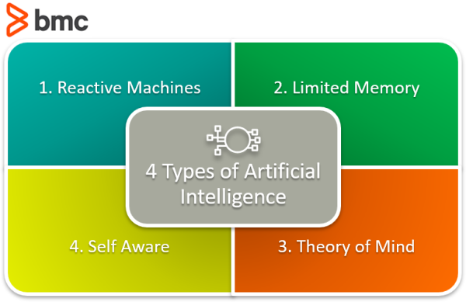
4.Self Aware

Reactive Machines
Reactive Machines perform basic operations. This level of A.I. is the simplest. These types react to some input with some output. There is no learning that occurs. This is the first stage to any A.I. system. A machine learning that takes a human face as input and outputs a box around the face to identify it as a face is a simple, reactive machine. The model stores no inputs, it performs no learning.

Static machine learning models are reactive machines. Their architecture is the simplest and they can be found on GitHub repos across the web. These models can be downloaded, traded, passed around and loaded into a developer’s toolkit with ease.

Limited Memory
Limited memory types refer to an A.I.’s ability to store previous data and/or predictions, using that data to make better predictions. With Limited Memory, machine learning architecture becomes a little more complex. Every machine learning model requires limited memory to be created, but the model can get deployed as a reactive machine type.

There are three major kinds of machine learning models that achieve this Limited Memory type:

Reinforcement learning
These models learn to make better predictions through many cycles of trial and error. This kind of model is used to teach computers how to play games like Chess, Go, and DOTA2.

Long Short Term Memory (LSTMs)
Researchers intuited that past data would help predict the next items in sequences, particularly in language, so they developed a model that used what was called the Long Short Term Memory. For predicting the next elements in a sequence, the LSTM tags more recent information as more important and items further in the past as less important.

Evolutionary Generative Adversarial Networks (E-GAN)
The E-GAN has memory such that it evolves at every evolution. The model produces a kind of growing thing. Growing things don’t take the same path every time, the paths get to be slightly modified because statistics is a math of chance, not a math of exactness. In the modifications, the model may find a better path, a path of least resistance. The next generation of the model mutates and evolves towards the path its ancestor found in error.

In a way, the E-GAN creates a simulation similar to how humans have evolved on this planet. Each child, in perfect, successful reproduction, is better equipped to live an extraordinary life than its parent.

Limited Memory Types in practice
While every machine learning model is created using limited memory, they don’t always become that way when deployed.

Limited Memory A.I. works in two ways:

A team continuously trains a model on new data.
The A.I. environment is built in a way where models are automatically trained and renewed upon model usage and behavior.
For a machine learning infrastructure to sustain a limited memory type, the infrastructure requires machine learning to be built-in to its structure.
Theory of Mind
We have yet to reach Theory of Mind artificial intelligence types. These are only in their beginning phases and can be seen in things like self-driving cars. In this type of A.I., A.I. begins to interact with the thoughts and emotions of humans.

Presently, machine learning models do a lot for a person directed at achieving a task. Current models have a one-way relationship with A.I. Alexa and Siri bow to every command. If you angrily yell at Google Maps to take you another direction, it does not offer emotional support and say, “This is the fastest direction. Who may I call and inform you will be late?” Google Maps, instead, continues to return the same traffic reports and ETAs that it had already shown and has no concern for your distress.

Self-Aware
Finally, in some distant future, perhaps A.I. achieves nirvana. It becomes self-aware. This kind of A.I. exists only in story, and, as stories often do, instills both immense amounts of hope and fear into audiences. A self-aware intelligence beyond the human has an independent intelligence, and likely, people will have to negotiate terms with the entity it created. What happens, good or bad, is anyone’s guess.

